FEEDBACK COLLECTION APP
@CREATIVITY THINK (9483175986/7019689991)

ABSTRACT:
The Feedback Collection App is a dashboard-based web application developed to streamline the creation, distribution, and analysis of feedback forms. It enables users to submit feedback, view aggregated insights, and access interactive analytics dashboards. Administrators can design custom forms, manage feedback entries, export analytical reports, and moderate responses. Built with Django and Django Rest Framework on the backend and React with Chart.js and React-Table on the frontend, the system ensures secure data collection, real-time visualization, and smooth interaction. This project enhances organizational decision-making by providing structured feedback acquisition and comprehensive analytics..

INTRODUCTION OF THE PROJECT:
Feedback is essential for organizational improvement, customer satisfaction, and performance assessment. Traditional feedback collection methods often lack structure, analytics, and automation, making evaluation inefficient. The Feedback Collection App provides a centralized system where users can submit feedback through customized forms, while administrators manage forms, review responses, and generate analytical reports. The application uses Django for backend operations and React for frontend visualization, ensuring seamless data handling and intuitive dashboards. This system serves diverse industries including HR, customer support, and market research by enabling structured feedback workflows and actionable insights..

PROJECT OBJECTIVES:

• To provide a centralized platform for collecting structured feedback
• To enable administrators to create, customize, and manage feedback forms
• To allow users to submit feedback easily and securely
• To provide analytics dashboards for visualizing collected responses
• To enable exporting of reports for documentation and decision-making
• To ensure reliable moderation and management of feedback data
• To improve organizational evaluations through data-driven insights

PROBLEM OF THE STATEMENT:
Organizations often rely on unstructured, manual, or inconsistent methods of gathering feedback, leading to data loss, delays, and difficulties in analyzing responses. Without centralized tools and automated analytics, identifying trends and making data-driven decisions becomes challenging. The Feedback Collection App provides a solution by offering form creation, structured response collection, real-time dashboards, and exportable reports. This ensures accurate data capture, comprehensive insights, and efficient management for both administrators and end users..

MOTIVATION OF THE PROJECT:
• Enable structured and centralized feedback gathering
• Replace manual and inconsistent evaluation methods
• Provide real-time analytics for performance and sentiment insights
• Improve decision-making using data-driven visual reports
• Enhance user experience with flexible form creation and submission

BLOCK DAIGRAM OF PROJECT:

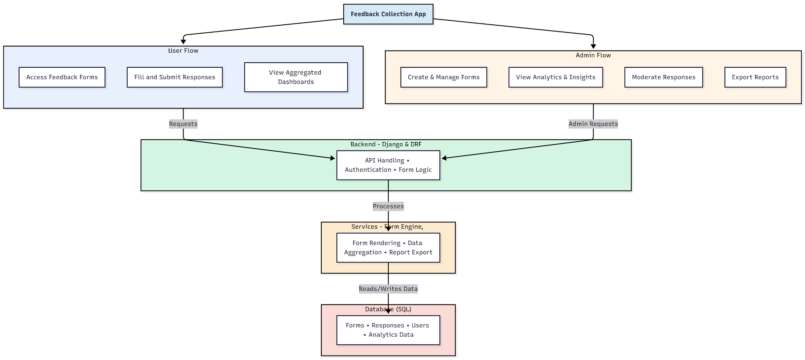

WORKING OF THE PROJECT:
Users access the platform, open custom feedback forms, fill in required fields, and submit their responses, which are stored in the system. Aggregated results automatically appear on analytics dashboards where users can view charts and trends. The backend manages authentication, API communication, form processing, and data validation, while analytics services handle data aggregation and report generation. Administrators create forms, manage feedback, review dashboards, export reports, and monitor overall system usage. This orchestrated workflow ensures seamless, structured, and data-rich feedback management for organizations..

SOFTWARE REQUIREMENT:
- Backend:
  - Python 3.x
  - Django
  - Django REST Framework
  - SQLite/PostgreSQL
- Frontend:
  - Node.js and npm
  - React.js
  - Axios
- Development Tools:
  - Visual Studio Code
  - Postman (for testing APIs)
  - Git/GitHub (for version control)
- Server/Deployment (Optional):
  - Gunicorn, Nginx, or Heroku/AWS for hosting

ADVANTAGES OF THE PROJECT:

• Centralized and structured feedback management
• Real-time analytics with visual dashboards
• Customizable form creation for various use cases
• Exportable reports for documentation and presentations
• Secure data handling with role-based workflows
• Easy moderation and response management
• Enhances evaluation and decision-making processes
• User-friendly interface for both users and admins

APPLICATIONS OF THE PROJECT:
• Customer support feedback systems
• HR employee satisfaction surveys
• College/University course feedback
• Market research and opinion surveys
• Performance evaluation platforms
• Product/service improvement programs
• Complaint and suggestion management
• Organizational quality assessments

REFERENCES:

- Django REST Framework Documentation — Django Software Foundation. Django Documentation. Available: https://docs.djangoproject.com/
- Django REST Framework. DRF Documentation. Available: https://www.django-rest-framework.org/
- React. React Official Documentation. Available: https://reactjs.org/docs/getting-started.html
- Redux. Redux Documentation. Available: https://redux.js.org/introduction/getting-started
- PostgreSQL Global Development Group. PostgreSQL Documentation. Available: https://www.postgresql.org/docs/
- MySQL. MySQL Reference Manual. Available: https://dev.mysql.com/doc/
- Git. Git Documentation. Available: https://git-scm.com/doc
- Node.js. Node.js Documentation. Available: https://nodejs.org/en/docs/
- Axios. Axios Documentation. Available: https://axios-http.com/docs/intro
- Socket.io Documentation – https://socket.io/docs/

